UNIT 4 PACKET
“IS GEEK THE NEW COOL?”

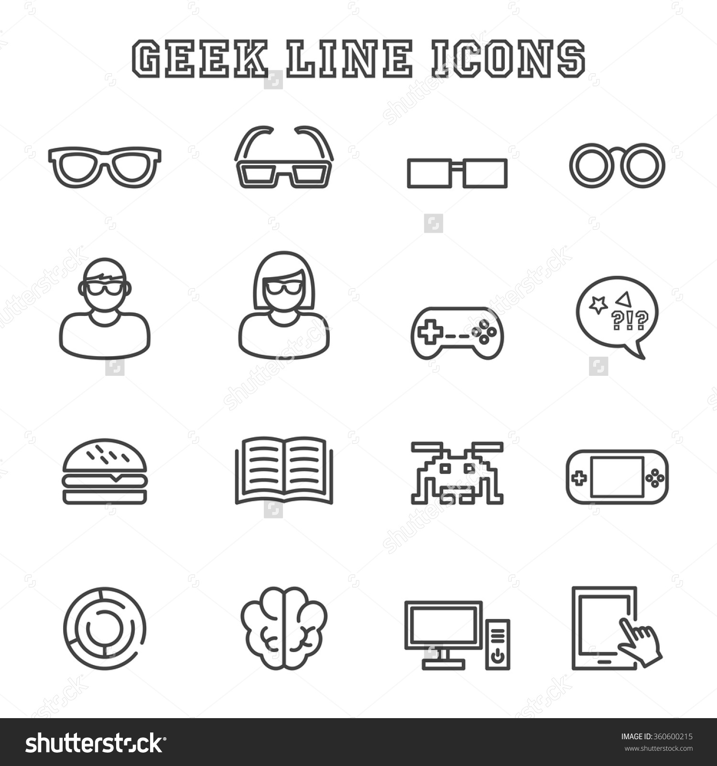

At the end of this unit, you will be able to….
- Describe “geeks”
- Write relative clauses using: who, whom, which, and that
- Write an essay using linking words about famous women in technology
- Create an avatar and write a social network profile
- Present a new type of social network

- Some changes: During this unit, we will have a total of 4 “pop quizzes” (unannounced quizzes) worth 5 points each, which will be put into the grade book. The quiz will cover homework or material learned in previous lessons in this unit. For example, if the homework is to read an article, the quiz will probably be questions from the article.
PLEASE REMEMBER TO BRING THIS PACKET TO EVERY CLASS.
(but because I have a heart of gold I will always bring extra copies)

- Lesson Dates –
Dates may change due to length of lesson, sick days, or extra days to review.
Lesson | 2A – Date | 2B - Date
- What’s a Geek?  *Reading Comprehension* | Wednesday Jan 11 | Thursday Jan 12
- Big Bang Theory pt. 1 | Thursday Jan 12 | Friday Jan 13
- Big Bang Theory pt. 2 | Monday Jan 16 | Tuesday Jan 17
- Virtual vs. Real Friends | Wednesday Jan 18 | Thursday Jan 19
- Grammar Review | Thursday Jan 20 | Friday Jan 21
- Voki – Computer Lab  *Make Social Media Profile* | Monday Jan 23 | Tuesday Jan 24
- Jigsaw: Famous Women in STEM | Wednesday Jan 25 | Thursday Jan 26
- How to write an essay | Thursday Jan 26 | Friday Jan 27
- Jobs in Tech | Monday Jan 30 | Tuesday Jan 31
- New Social Media – Computer Lab | Wednesday Feb 1 | Thursday Feb 2
- New Social Media – Computer Lab  ** Essay Due ** | Thursday Feb 2 | Friday Feb 3
- Exam | Monday Feb 6 | Tuesday Feb 7
- Social Media Presentations | Wednesday Feb 8 | Thursday Feb 9

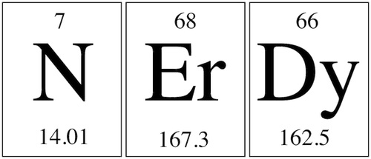

Lesson 1 : What’s a Geek?
Activity: Look at the vocabulary words below. With a partner, put each word into the correct category. If you can think of more words, add them!

Appearance Interests

Behaviour / Personality “Non Geek” (Mr. Cool / Miss Popularity)

Friendly Mechanical Unemotional Intellectual Superior
Well / Poorly dressed warm =/= cold sci-fi (science fiction) Tie
Obsessive Perfectionist Music / Musical Math Sensitive
Reluctant = reticent accident-prone (gauche) Clumsy (maladroit) Astrology
Hapless (malchanceux) Committed = Dedicated Passionate Sociable
Awkward = embarrassed Lazy Glasses Cardigan Plain Bow-tie
Attractive Serious =/= light hearted Intelligent Athletic Braces
Bossy Pain Loyal Selfish Sociable Dutiful Fake

Homework: Read the article about Geeks Pride Day and answer the questions. There might be a quiz next class!!
Geek Pride Day
Nerd Pride Day, also called Geek Pride Day, is a fun and serious day that celebrates nerds and geeks. Anyone around the world can feel proud to be a nerd or geek on this day. The day started in 2006 and takes place on May 25. This is a very special date because it is the world premiere of the first Star Wars movie in 1977. The day is a Spanish creation but crossed the Atlantic in 2008. It is now officially celebrated in America and other countries. Many nerd and geek bloggers hold parades and write special blogs about nerdiness and geekiness. There is a manifesto that contains the basic rights and responsibilities of nerds. This includes the right to be “even nerdier;” to “not leave your house;” and to “have few friends (or none at all)”.
It is hard to find a definition of a nerd or geek on the Internet. Perhaps the best clue is; “You know one when you see one.” A few common characteristics of nerds and geeks might include the following: 1. Having dreams of achieving things normal people don’t have. 2. Being unusually interested in technology, especially more unusual hardware and software. 3. An interest in a hobby or pastime others might think is obsessive. Geeks are extremely important to society. It was because they stayed at home, had big dreams and spent hours every day on their hobby that we now have computers. Nerds and geeks tend not to be interested in modern fashions and are not always the best at sports and dancing.
Sources: http://www.wikipedia.org/ and assorted sites.
Comprehension Questions:
- What is a synonym for “geek”?

- When does Geek Pride Day take place?

- Where is Geek Pride Day celebrated? Where did it originate from?

- What is important about the date?

- Name one “right” to being a nerd.

- Typically, what subject is interesting to nerds?

- How would one describe a nerd’s level of interest, regarding hobbies or pastimes?

- How have geeks contributed to today’s life?

Lesson 2: The Big Bang Theory
WATCH the interaction between Penny, Sheldon and Leonard from the pilot (first episode) of “The Big Bang Theory”. How can you describe these characters, using the vocabulary from lesson 1?
The Big Bang Theory - Synopsis and characters
The Big Bang Theory (or TBBT) is an American television sitcom which premiered on CBS on September 24, 2007.
The show focuses on five characters living in Pasadena, California: Leonard Hofstadter and Sheldon Cooper, who share an apartment and are physicists; Penny, a waitress and aspiring actress who later becomes a pharmaceutical representative and who lives across the hall; and Leonard and Sheldon's equally geeky and socially awkward friends and co-workers, aerospace engineer Howard Wolowitz and astrophysicist Raj Koothrappali. The geekiness and intellect of the four men are contrasted for comic effect with Penny's social skills and common sense.
- Leonard Hofstadter is an experimental physicist who received his PhD when he was 24 years old and has an IQ of 173. Like all of the other major male characters, Leonard is a nerd who loves video games, comic books and Dungeons & Dragons. Leonard is also lactose intolerant. The straight man of the series, he shares an apartment in Pasadena with Sheldon. Leonard is smitten with his neighbor Penny when they first meet. They date on and off throughout the series.

- Sheldon Cooper was a child prodigy with an eidetic memory who began college at the age of eleven (after completing the fifth grade), started graduate studies at age fourteen and earned a PhD at age sixteen. As a theoretical physicist researching quantum mechanics and string theory, he has two doctoral degrees. Sheldon has a poor understanding of others' feelings. He boasts of his superior intelligence and belittles his friends' accomplishments, making him appear petty and childlike. Sheldon has an extremely ritualized way of living (such as always sitting in the same spot on the sofa, or knocking on a door three times, each time saying the name of the person whom he is addressing) and a compulsion to complete things.
- Penny is an aspiring actress from a town outside of Omaha, Nebraska. Penny moves in across the hall from Sheldon and Leonard in the series premiere. To pay her bills, she is a waitress at the Cheesecake Factory, although she often relies on the guys for free food, Wi-Fi and help paying her rent. Penny attended, but did not graduate from, community college. She, however, has far more common sense and social awareness than the rest of the gang. Penny is also untidy and frequently consumes alcohol.
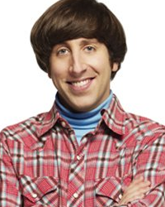
- Howard Wolowitz is an aerospace engineer who lives with his mother. Unlike Sheldon, Leonard and Raj, Howard lacks (doesn’t have) a doctorate, earning him Sheldon's scorn. He defends this by pointing out that he has a master's degree in engineering from the elite Massachusetts Institute of Technology and that the apparatuses he designs are launched into space, unlike the purely abstract work of his friends. In the early seasons of the show, Howard fancies himself a womanizer and devises outrageous pickup lines, which have limited success with women.
-Rajesh Koothrappali is from New Delhi and is a particle astrophysicist at Caltech. Raj is bashful (shy) around women and is unable to talk to them for the first six seasons. Even so, he often has better luck with women than his overly-confident best friend, Howard. Raj also has very feminine tastes and often takes on a stereotypical female role in his close friendship with Howard but he insists that he is not gay.

Lesson 2: Continued
- Grammar: Relative Pronoun “Who”
Look at the sentences below.
Leonard is a physicist. He received his PhD when he was 24 years old.
- Leonard is a physicist who received his PhD when he was 24 years old.
Sheldon was a child prodigy. He began college at the age of eleven.
- Sheldon was a child prodigy who began college at the age of eleven.
Penny is the cute neighbor. She lives across from Leonard and Sheldon.
- Penny is the cute neighbor who lives across from Leonard and Sheldon.

**Note: A clause is a sentence that has a subject and a verb. A relative clause provides more information.
- In the examples above, we begin with how many clauses?
- In the examples above, the subject of the clauses are : the same different
- What word do we use to combine the two clauses?
^ This word is called a “relative pronoun” because it introduces a relative clause.
- The relative pronoun has what grammatical function? Subject Object
- Why do we use “who”?
- When we use the relative pronoun “who”, it is: necessary / not necessary to repeat the subject.

Now, it’s your turn. Combine the clauses below. For more exercises, look at the attached worksheets.
Howard is an aerospace engineer. He lives with his mother.
- ___________________________________________________________________________________
Raj is their Indian friend. He is too shy to speak with women.
- ___________________________________________________________________________________
Do you know the girl? She is talking to Tom.
- ____________________________________________________________________________________
That’s my friend’s dog. He doesn’t like me.
- ____________________________________________________________________________________
Instead of saying “who”, we can instead say “that” to refer to people in a relative clause.
Leonard is a physicist that received his PhD when he was 24 years old.
Using “who” and “that” are both correct, but for the unit exam and for Cambridge exams, it is preferred to use “who”.

Exercises: Relative Pronoun “Who”
Combine the two sentences.
1. He is the one. The award should be given to him.
He is the one __________ the award should be given to.
2. This is Mary. She is taking over my job when I leave.
This is Mary, __________ is taking over my job when I leave.
3. The people were stopped at the border. They were all from Eastern Europe.
The people __________ were stopped at the border were all from Eastern Europe.
4. The man spoke. He is my father. ___________________________________________________________________________________
5. We gave a tip to the waiter. He was very pleased. ___________________________________________________________________________________
6. The man you saw yesterday. He is my uncle.
___________________________________________________________________________________

Lesson 3: The Big Bang Theory (Continued)

Getting to Know You : Penny
Read the paragraph below.
Circle the relative pronoun “who” and underline the relative pronoun “whom”
----------------------------------------------------------------------------------------------------------------
Hey there! I’m Penny, the new neighbor who lives across from Leonard and Sheldon. They are my new friends whom I hang out with a lot. Before I moved there, I lived in another part of the city. My “roommate” was a jock whom I went out with for four years. My ex and the new guys are polar opposites, but I really do like Leonard. In fact, I’m the girl whom he’s falling in love with! It’s pretty obvious. Anyways, I depend a lot on the guys for food and WiFi because I’m broke. I had a rich uncle whom I inherited a lot of money from, but I spent all the money to move across the country. Remember the jock whom I told you about before? He kept the TV that I bought! What a jerk!
Compare these two sentences.
- I’m the new neighbor who lives across from Leonard and Sheldon.
- They are my new friends whom I hang out with a lot.

- In sentence A, the relative pronoun is what part of speech? Subject Object

- In sentence B, the relative pronoun is what part of speech? Subject Object

- In sentence B, the two clauses have : the same different subjects.

- In sentence B, the complete verb (a phrasal verb!!) contains a preposition: yes no

Do we always need a relative pronoun? Nope! Look at the sentence below.
Raj is the guy _X_ (or “who”) you called yesterday.
De-construct the above sentence and write it into two.
The clauses above have : the same different subjects.
The relative pronoun would be the : subject object in this sentence, so we can omit it.
1. Using “whom” is extremely formal and hardly used in informal speech. Also, Americans never use “whom” – instead “who” is used.
2. Again, “that” can be used instead of “who” when referring to people in relative clauses.
For Cambridge and the Unit Exam, you must use “whom” or “who” for people [not that].

Relative Pronoun “Who”, “Whom”, and (no pronoun) – Exercises
Fill in the missing word, when necessary.
- She’s the only person _____________ really understands me.
- Where’s the girl _______________ is selling ice-cream?
- This is George’s brother, with _______________ I went to school.
- I know the man _______________ you met.
- The uncle _______________ you told me about is really intelligent.
- The teacher _______________ taught me English has died.
- The student _______________ you like very much has called.
- Here’s my sweet little brother _______________ is very fond of video games.

Translate the following sentences:
- Demain, je rencontrerai l’homme qui a inventé l’écran tactile.
- Il va me présenter la personne avec qui il a travaillé.
- C’est vraiment la personne que j’ai toujours rêvé de rencontrer.
Need some more help?
Student book: pg. 68, pgs. 257-258.
Attached worksheet: Unit 101-102 (also talks about relative pronoun “which” – next lesson)

Homework for Lesson 4: Look at your various social media accounts (Facebook, Instagram, Snapchat, etc). How many friends do you have on each of them? How many of these “friends” do you know in real life?
Read the article below and answer the comprehension questions.
Lesson 4: Virtual or Real Friends?
Best of Friends
A recent survey says people are happier and laugh 50% more when talking to a friend face-to-face. So it’s safe to conclude that virtual friendships don’t count anymore.
We have hundreds of, some even have 1,000-plus, friends on social networking sites, but only a handful of “real” ones. Real friends whom we hang out with, share personal details and spend quality time with. And yet, we keep chatting with our virtual friends on social networking sites almost on a daily basis, instead of nurturing¹ real friendships.
Virtual friends are no substitute for real ones
Friends on social networking sites cannot be a substitute for real friends, says psychologist Mansi Hasan, adding, “Social networking sites are the easiest way to keep in touch with those countless people who we wouldn’t be able to keep in touch with due to our busy lives”.
Face-to-face interactions are more satisfying
The reason could be that the human brain reads subliminal clues, which go beyond the individual reading of gestures, facial expressions and words.
Source: www.articles.timeofindia.indiatimes.com (classbook pg. 62)
- enrichissante
Comprehension Questions
- What did the survey say about virtual friends compared to real friends?

- What is the number of real friends we have?

- What are the differences between real and virtual friends?

- How is social media a good thing regarding friendships?

- Grammar : Relative Pronoun “which”
Look at the sentences below. Remember, a relative clause is a sentence that provides more information about the antecedent.
- Subliminal clues which go beyond the individual reading of gestures.

- They’re making a new social network which will replace Snapchat.
- Computers which have changed our lives.
- The app (which) she created is very successful.

- In the above sentences, “which” is used as: the subject __________ the object ________

- “Which” represents: humans non-humans
- Why isn’t there a relative pronoun in the final phrase?

We can also use “that” as a relative pronoun for things [and for people]:
A thief is a person who / that steals things.
An airplane is a machine which/ that flies.
For Cambridge and the Unit Exam, it is better to demonstrate your knowldege by using a variety of who/that and which/that.

For additional explanations, check out the following pages:
Student book: pg. 68, pgs. 257-258
Attached worksheet: “Unit 101”, “Unit 102”
Attached worksheet: “Relative Clauses”

Fill in the missing word, when necessary.
- The computer _______________ I was given at Christmas was made by a Japanese company.
- The car _______________ is parked in front of my house isn’t mine.
- I have decided to sen him a letter _______________ will surprise him.
- We broke the computer _______________ belonged to my father.
- The table _______________ you bought is an antique.
Translate the following sentences.
- L’ordinateur que tu m’as acheté ne marche plus.
- Le cerveau humain, qui a été beaucoup étudié, reste un mystère.
- Le téléphone avec lequel je t’appelle est coréen.
- Relative Clauses : Who, Whom, Which, [That], or no relative clause. [Quiz next class… maybe?!]
Write the missing relative clause: Who, whom, which or none
Final del formulario
- He bought all the tools _______________ are required to fix his old car.
- This is the doctor _______________ helped Sara recover from her illness.
- This is the girl _______________ he fell in love with in Madrid
- She managed to pass the exam in spite of all the difficulties, _______________ didn't surprise people who knew her.
- They had four children, all of _______________ went to university.
- Give me the plate _______________ is on the table.
- I don't know _______________ did it.
- That’s a song _______________ reminds me of my youth.
- The criminals, two of _______________ managed to escape, broke into a bank downtown.
- I know the candidate _______________ I am going to support in the next elections.

Lesson 5 : Grammar Review Day
Lesson 6: Computer Lab – Create a Voki
For this lesson, we will visit Voki.com and create an avatar. You can personalize your avatar anyway you want. Then, make a one minute recording “introducing” your avatar and send it to Ms. T: mvtaepke@yahoo.com.
Finally, print off a picture and write a social media profile, using the “geeky” vocabulary we used in class. This will be turned in to Ms. T for lesson 7.

Lesson 7 : JIGSAW / Reading Comprehension - Famous Women in Science and Technology
In class, you will receive a short biography about a famous woman in science and technology. You will read the text and with a group, talk about what interesting information you learned. Then, you will make new groups and share your information with others.
** Share important information and take notes! Possible Quiz for the next class!**
For the writing assessment this unit, you must research a different famous woman in science and technology and write a one page essay about her and her accomplishments.

In the writing, you must include: (worth 0.5 points for each word correctly used)
- Relative Pronouns
  - Who x3
  - Whom x2
  - Which x3
  - That x3
- Linking Words x 7 [taught in lesson 8].
- One sentence in the passive voice [worth 1 point]
The writing must be typed, doubled spaced, and will be due on Lesson 11

Lesson 8 : How to write an essay
Lesson 9 : Jobs in Technology
The speaking portion of this unit is to work in small groups (3-4 people) and create a new type of social media. [student book pg. 70]
Working together, make a powerpoint presentation that includes the following information:
- How does it work (website, application: web, smartphone, tablet…)
- A symbol and example of it in use
- Who is it for (teens, music-lovers, everybody)
- Why you’re sure it will be successful
- Examples: Flutter (Twitter + Flicker), Spacebook (Sci-fi Friends), Joogle (Google for jokes), Samsongs (i-tunes alternative)
The powerpoint must be 8 pages long, including the title page.
You will present the powerpoint in class. Each person must speak the same amount of time (about 2 pages/slides each). About 20 seconds for each page would be ideal.
You will present the powerpoint to the class on Lesson 13.
Lesson 10 + 11:
Computer Lab

Lesson 12 : Test

Lesson 13: Social Media Presentations

What will be on the test?

- Grammar: Relative Pronouns – Who, Whom, Which, That, or none.

- Vocabulary: Describing a geek, New Tech Industries, Real or Online Friends

- Past Grammar: Comparatives, Superlatives, Passive Voice, Gerunds as subjects, Could for suggestions….

- Listening comprehension

- Reading comprehension

Relative clauses : What is a relative clause?
We can use relative clauses to join two English sentences, or to give more information about something.
I bought a new car. It is very fast.
→ I bought a new car that is very fast.

She lives in New York. She likes living in New York.
→ She lives in New York, which she likes.

Defining and Non-defining
In this unit, we are learning about defining relative clauses (no commas)
A defining relative clause tells which noun we are talking about:
- I like the woman who lives next door.
(If I don't say 'who lives next door', then we don't know which woman I mean).
A non-defining relative clause gives us extra information about something. We don't need this information to understand the sentence. The extra information is within commas ( , ).
- I live in London, which has some fantastic parks.
(Everybody knows where London is, so 'which has some fantastic parks' is extra information).

Defining relative clauses:
1: The relative pronoun is the subject:
First, let's consider when the relative pronoun is the subject of a defining relative clause.
-We can use 'who', 'which' or 'that'. We use 'who' for people and 'which' for things. We can use 'that' for people or things.
-The relative clause can come after the subject or the object of the sentence. We can't drop the relative pronoun.

For example (clause after the object of the sentence):
- I'm looking for a secretary who / that can use a computer well.
- She has a son who / that is a doctor.
- We bought a house which / that is 200 years old.
- I sent a letter which / that arrived three weeks later.
More examples (clause after the subject of the sentence):
- The people who / that live on the island are very friendly.
- The man who / that phoned is my brother.
- The camera which / that costs £100 is over there.
- The house which / that belongs to Julie is in London.
2: The relative pronoun is the object:
Next, let's talk about when the relative pronoun is the object of the clause. In this case we can drop the relative pronoun if we want to. Again, the clause can come after the subject or the object of the sentence. Here are some examples:
(Clause after the object)
- She loves the chocolate (which / that) I bought.
- We went to the village (which / that) Lucy recommended.
- John met a woman (who / that) I had been to school with.
- The police arrested a man (who / that) Jill worked with.
(Clause after the subject)
- The bike (which / that) I loved was stolen.
- The university (which / that) she likes is famous.
- The woman (who / that) my brother loves is from Mexico.
- The doctor (who / that) my grandmother liked lives in New York

