2nde – Unit 3 Packet – How Do You Love Me
Lesson 1 – Online Dating
Intro Discussion:
Which apps do you know and use? What do you use them for? Why do you like / dislike them?
What do you think about online dating and apps like Tinder? Would you do online dating? What are some advantages and disadvantages?

Short Film: 97%
Here are 10 scenes that happen in the film. Put them in the order that you think they occur. Then, watch the film and check if your order is right. If not, write the correct order.
Scenes My Order Film’s Order
a.A man looks at the photo of a smiling woman on his mobile. _______ _______
b.A woman hugs and kisses a man. _______ _______
c.A man climbs over a barrier. _______ _______
d.A man walks along a street. _______ _______
e.A man loses his Internet connection. _______ _______
f.A man gets off a train. _______ _______
g.A man smiles at the woman sitting opposite him. _______ _______
h.A man looks at another man wearing glasses. _______ _______
i.A man standing on a platform looks at a woman on a train. _______ _______
j.A man gets stuck in a train’s doors. _______ _______

Follow Up Discussion:
Do you think it’s possible to find love anywhere thanks to dating apps and smartphones?

Do dating apps like Tinder make dating less romantic?

HOMEWORK: Watch the trailer for the documentary “Catfish”. What do you think will happen? (if we don’t watch it in class, watch it at home before doing the homework assignment). Read the article about Catfishing

Lesson 2: Dating Help
Intro Discussion:
What are some “red flags” when you meet somebody online? In your opinion, is online dating safe?
Are you (or somebody you know) dating? How did you / he / she meet this person?
- When you have problems (school, dating, life in general), who do you talk to? Do they give good advice? What’s a problem you recently had?
Letters to the Agony Aunt (Claire):
Listen to a letter that Alexis wrote to Claire, the Agony Aunt, asking for advice. Answer the following questions.
- Why did Alexis start to use an online dating app?

- Why is Alexis into this guy?

- What does this guy do that seems “weird”?

- What is important to Alexis?

- What is your opinion about this situation?

WWYD? (What Would You Do?)
Give some advice to Alexis about her dilemma.

Grammar: Gerunds
Read the letters below from Alexis and Claire. Find all of the gerunds (verb+ing).

What part of speech is the gerund in these letters?

Dear Claire,
Meeting guys in my school is impossible, so I started to use an online dating app. A few weeks ago, I think I met my match – this guy is perfect in every way. He’s really cute (OMG in his pics he looks like a Hollister model!), he likes to play sports, and we have the same interests. What’s even better is that he lives really close to me! We text all the time and he sends the sweetest messages. As they say, “seeing is believing” and I want to meet him, but he always has some lame excuse. Having a real (in person) relationship is important for me but I don’t like these mixed feelings. Do you think he’s the real deal?
Alexis
--------------------------------------------------------------------------------------------------------------------------
Dear Alexis
Dating is never easy, whether it’s online or in person! Meeting people online is totally normal nowadays, but being smart and safe is really important. Catfishing, or creating a fake online profile, is becoming a big problem. I hate to break your heart, but your crush might not be the heart throb you think he is – in fact, he might be some old creepy guy. Try to meet people in person so you don’t waste your time!
~Claire

The Many Faces of Gerunds (pg. 254-255)
Gerunds are verbs that end in –ing (meeting, dating, reading…) and they function as a noun. Just like nouns, they have many uses:
As the subject of a sentence: Reading helps you learn English.
As the complement of a sentence: Her favourite hobby is reading.
As the object of a sentence: I enjoy reading.
-It is important to know that objects can be the infinitive or gerund (ie: I enjoy cooking / I want to cook). It depends on the main verb if the gerund or infinitive is used.
In this unit, we will focus on gerunds as the subject
Dating is normal for many teenagers.
Going to the movies is a great first date.
Not looking your best is a bad idea.

Practice: Write a paragraph with some dating do’s and don’ts, using the gerund as the subject.

File 1 Vocabulary (pg. 46-47)
Crush Match Partner Date Boyfriend/Girlfriend Safe Dangerous Make friends with SB Give Advice Look one’s best Feel shy Intimidated Swipe right/left The Real Deal

HOMEWORK: Many people say that “love is blind”. What do you think that means? (Hint: think about the Duchess Cayetana and Alfonso Diez Carabantes, Heidi Klum and Seal (now broken up ), Prince William and Kate Middleton, Mary-Kate Olsen and Olivier Sarkozy.

Lesson 3: Forbidden Love?
Intro Discussion: In the past, a typical couple was considered a man and a woman of the same age and race. Has this changed? What types of couples do you see nowadays?
“love is blind” – what do you think this means? What are some examples?
What is “forbidden love”? The classic example is from Shakespeare’s Romeo and Juliet. Why was their love forbidden? What happened in the story?
Romeo & Juliet Balcony Scene
- Unit 3 Project / Speaking Assessment: We will watch some clips from Romeo & Juliet films and read the script. With a partner, re-write the script using current language. For lesson 6, you and your partner will act out the scene in class.
Assessment Guidelines
 | Creativity: New script is original, provides the same message as the original Shakespeare play. | Use of English: uses current-day vocabulary, slang, sentence structure, gestures. | Oral Presentation: Pronunciation does not interfere with understanding, script is memorized, and dialogue is spoken loudly for all to hear. | Presentation: well prepared and practiced, appropriate use of props, maintains interest of the audience.
Outstanding -5
Above Average -4
Average -3
Below Average -2
Unacceptable -1
File 2 Vocabulary (pgs. 48-49)
Fairy tale mixed couple to be colour-blind to be open/narrow minded hit the jackpot gender an outcast to be excluded to be discriminated against to break traditions

HOMEWORK: What is a marriage proposal? Do you know of some examples (classic or non-traditional)? Are proposals common in your culture or is it more of an American thing? Look up some proposals on YouTube (especially the “marriage proposal fails”!).
Lesson 4: Will You Marry Me?
Intro Discussion: What are some marriage proposals you saw on YouTube? Which ones did you like? Which ones didn’t you like? What do you think about them?

Video Comprehension: Watch a short news story about popular marriage proposals and answer the following questions. We’ll watch the video twice.
- What are some adjectives the news anchor uses to describe wedding proposals?

- Describe Shumaila’s proposal.
- How much did the choreographer cost her fiancé?
- Josh spent how much money on the complete proposal?
- What was Josh’s reason for planning and spending so much on the proposal?

- What’s the average price of a wedding?
- What does Sarah Pease do?
- Sarah says for the fiancé(e)-to- be to say “yes”, what is important?
- How much does she charge for her service?
- What are some examples of proposals shown?
- What should couples think about before doing an extreme proposal?

Grammar: Could (pg. 54, pg. 245 - 246)
Look at the sentences below that use “could”. Which is: a request, a possibility, a conditional, a suggestion, a past ability?
- Extreme rain could cause the river to flood the city. _______________
- Nancy could ski like a pro by the age of 11. _______________
- You could see a movie or go out to dinner. _______________
- Could I use your computer to email my boss? _______________
- We could go on the trip if I didn’t have to work this weekend. _________

-After “could” we use ________________ (just like with “must” and “should”)

Writing Practice
Imagine that your older sibling (brother / sister) wants to propose to the love of his/her life, and he/she has asked you for help. Write an e-mail to your sibling, providing him/her with some suggestions (hint hint – see the grammar!).

Lesson 5 prep: Are your parents, siblings, relatives married? Was it a traditional church marriage or a civil union? Is it still common to get married these days or no?
HOMEWORK: Read the article about why Millennials are waiting so long to get married, or not get married at all. Answer the comprehension questions.
File 3 Vocab (pg 50-51)
Unusual Unconventional Remarkable Astonishing Be taken aback Be put off
Convince Dissuade Be reluctant Spontaneous Feel astounded
Be over the moon Stage a proposal Invite performers

Lesson 5: To Wed, or not to Wed
In the past, it was normal for girls and boys to get married in their late teens or early 20s. Now, the average age for marriage keeps increasing. The average age for millennials (people born between 1980-2000) to wed is around 26, if they get married at all. Why do you think that is?
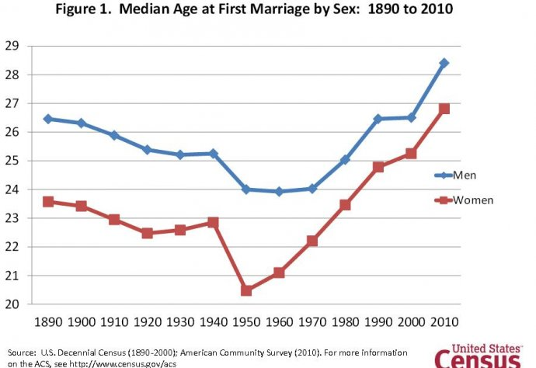

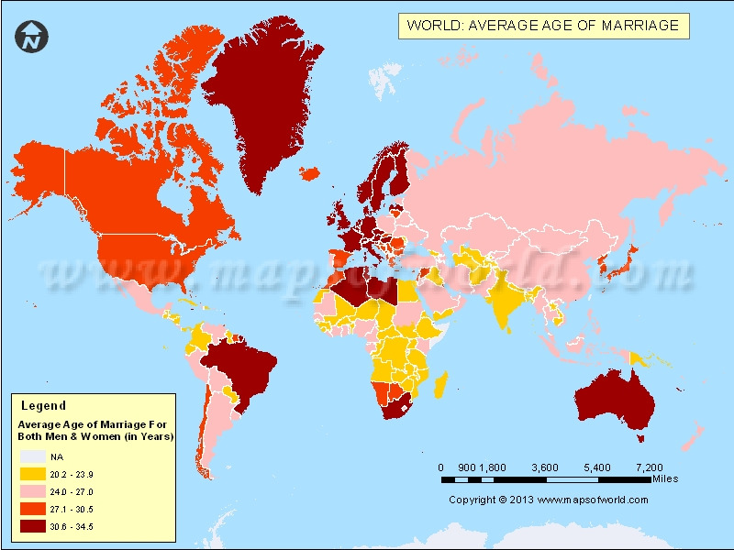

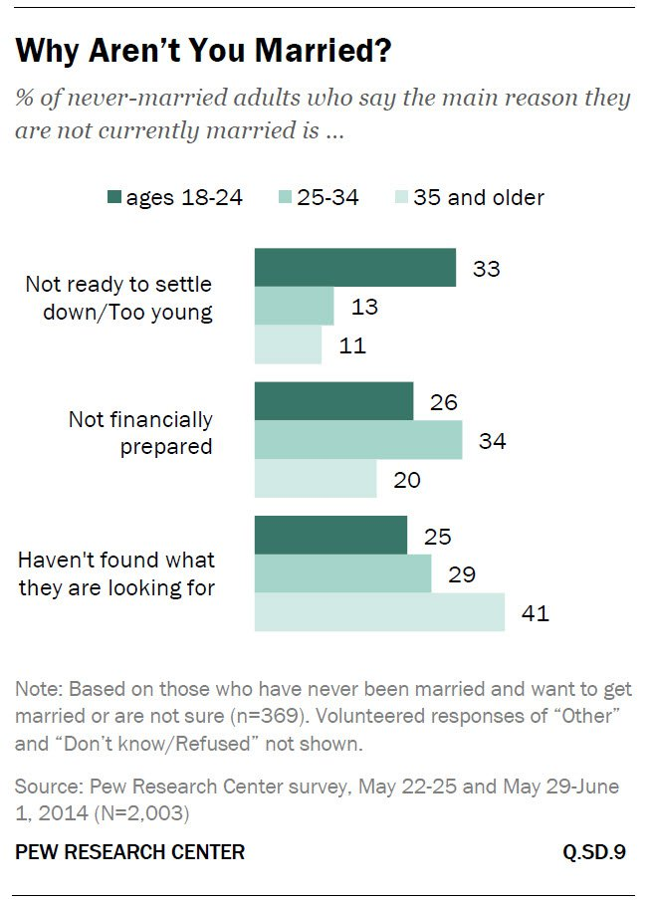
Why 25% of Millennials Will Never Get Married

A new report from Pew Research predicts that more folks under 35 will be single forever. Here's why:
The number of Americans who have always been single and will never marry is at a historic high, says a new Pew Research report, partly because they don’t have jobs and partly because marriage is becoming less highly-regarded. Most people think it’s important for couples who intend to stay together to be married, but the number of single Americans who want to get married has dropped significantly even in the last four years.
The report, based on census data and Pew’s surveys, is the latest in a series of indicators that marriage is on a sharp downward trajectory. Fewer young people are getting married and many are getting married later. About 20% of Americans older than 25 had always been single in 2012, up from 9% in 1960.
Why aren’t people getting married anymore? The three main reasons people give for their singleness are that they haven’t found the right person (30%), aren’t financially stable enough (27%) and are not ready to settle down (22%). Many more young people are putting off tying the knot, at least for a while, for shacking up. The researchers don’t see that as the new normal yet. “Cohabitation is much less common than marriage and cohabiting relationships are much less stable than marriages,” says Parker.”It’s hard to imagine marriage being replaced any time soon.”
But the Pew researchers teased out a bunch of other reasons by asking what people wanted in a partner.
The quality most women want in a husband, somewhat unromantically, is a secure job, followed very closely by similar ideas on raising kids, which was the quality most men wanted in a spouse. The problem is, the report points out, that young men are increasingly less likely to be employed. “In 1960, 93% of men ages 25 to 34 were in the labor force; by 2012 that share had fallen to 82%.” Those young men who are employed are not bringing home as much bacon as they once did. In fact, if you adjust for inflation, the median hourly wages of men aged 25 to 34 are a fifth less than they were in 1980.
Compounding that issue is that women have entered the labor force in much higher numbers. So while there are more men than women who are single and available, there are far fewer employed men who are single than employed women.
But don’t let that bum all the single ladies out too much, the report points out that single young women don’t have to marry single young men: they can marry guys who are divorced, widowed or much older. Should they bother?
“Marriage hasn’t fallen out of favor,” says Parker, “but financial constraints and imbalances in the marriage market may be holding people back from taking the plunge.”
Source: http://time.com/3422624/report-millennials-marriage/
Comprehension Questions :
- Many people aged 18-24 state which reason for not being married yet?

- Why haven’t “older” people (35+) settled down? (get married)

- What is a new “trend” regarding getting married?

- Why are so many couples co-habiting?

- What do women look for in a man? What do men look for in a woman?

- What has changed in the work force over the past few decades?

IN-CLASS DISCUSSION: Is the view about marriage in Spain/France/Europe the same as in the USA? Why/ why not?

Here comes the bride…. What are weddings like in Spain/France? Have you been to one? What are some traditions? Compare them to American weddings. (Google image/video: American Weddings – there are some really unique ones!)

Grammar: Will (pg. 55)
Will you marry me? - Yes, I will! -No, I won’t!
File 4 Vocab (pg. 52-53)
Wedding ceremony Bride & Groom Wedding Dress Tux (tuxedo) To marry SB
To get married Exchange vows hold hands look into SB’s eyes

Writing Assessment: The school newspaper has asked you to write an article about dating advice. TYPE an article (approx. 150-180 words) with some dating do’s and don’ts. (hint hint – wink wink – use the grammar we learned in this unit!)
This will be collected on Lesson 7

Lesson 6: Romeo & Juliet Presentations
Lesson 7: A) Review Day OR B) Exam (will you be ready?
Lesson 8: A) Exam OR B) Movie: The Princess Bride
Lesson 9: Movie

