3EME – UNIT 3 PACKET
SURPRISING AUSTRALIA

- Some changes:
During the unit, we will have 4 “Pop Quizzes” [surprise quizzes] of 5 questions each. The quiz will be on what was learnt in previous classes in this unit and the total score will be put into the grade book.
Make sure to always do some practice activities and read the assignments!
At the end of this unit, you will be able to:
- Compare Australia with other countries
- Discuss the biodiversity in Australia
- Write a job description
- Prepare and have a job interview
- Identify Australian English and culture
- Talk about past experiences

Please remember to bring this packet to class!
You can also download a copy at misstaepke.weebly.com
Lesson Schedule
**Dates of the lessons may change due to sick days, review days, or other complications**
Lesson | Date
1 – Australia KWL | Friday Jan 13
2 – Visit Australia – Tourism Video  - Holiday Activities Vocab | Monday Jan 16
3 – Have you ever….? Holiday Activities | Wednesday Jan 18
4 – Life Experiences - Present Perfect vs. Past Simple | Friday Jan 20
5 – Learn to speak Aussie  - Life Down Under  *Homework: Read and prepare JIGSAW* | Monday Jan 23
6 – JIGSAW – Australian Biomes / Jobs | Wednesday Jan 25
7 – Awesome Australian Animals (1) - Comparatives | Friday Jan 27
8 – Awesome Australian Animals (2) - Superlatives | Monday Jan 30
9 - Job Adverts | Wednesday Feb 1
10 – Job Adverts and Applications (1)  *Adverts due at the end of the hour* | Friday Feb 3
11 – Job Adverts and Applications + Speaking prep (2) | Monday Feb 6
12 – Test Review / Job Interviews? | Wednesday Feb 8
13 – Test | Friday Feb 10
14 – <3 Valentine’s Day Fun! <3 | Monday Feb 13
15 – Job Interviews (1) | Wednesday Feb 15
16 – Job Interviews (2) | Friday Feb 17

Lesson 1: Australia KWL – What do you Know? What do you Want to know? What have you Learnt?
In this unit, we are going to learn a lot about Australia. Australia is pretty big, and pretty far away! Let’s begin by filling out this chart.
What are some things that you already know about Australia? (it’s ok if you aren’t sure if it’s true!)
What are some things that you’d like to learn about Australia this unit?
And finally, when we finish the unit, we will come back and fill out the final part – What have we learnt about Australia.

Lesson 2 : What to do in Australia
Look at the map below of Australia. Do you know what the geography of Australia is like? Are there deserts? Rainforests? Snow-capped mountains? What type of activities can you do there?
KEY
= Mountains
= Desert
= Rainforest
= Coast
Make a key and complete the geographical map of Australia (on the board).
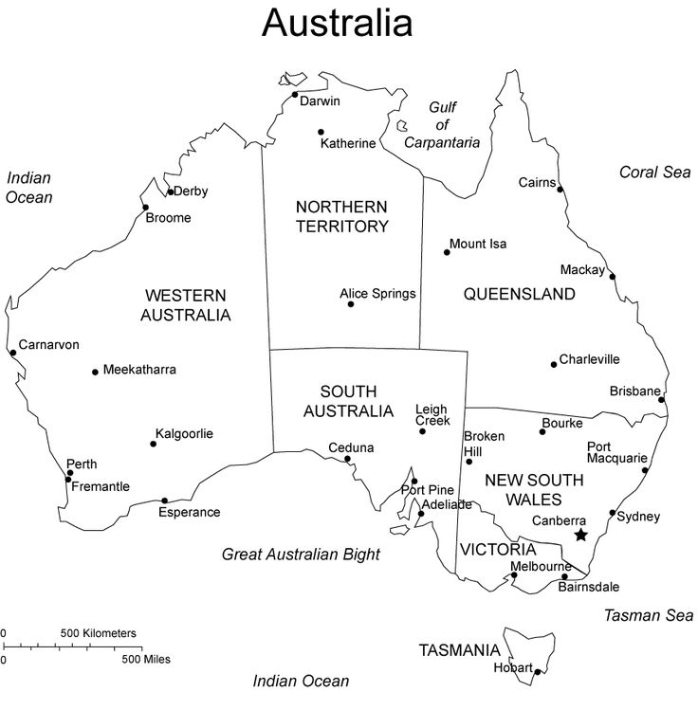

Watch a tourism advert for Australia. Which cities are shown? Circle them on the map.

Based on the clip, what activities can you do in Australia? Did any of them surprise you?

Lesson 3 : Have you ever….?
What are some activities that you like to do on holiday?
Are these activities…. Relaxing? Exciting? Cultural? Educational? Boring?

Listening: A “thrill- seeker” is a person who likes to do high- adrenaline activities. Listen to this thrill-seeker tell us about the different things they’ve done. Look at the map below, find the location, and write the activity.
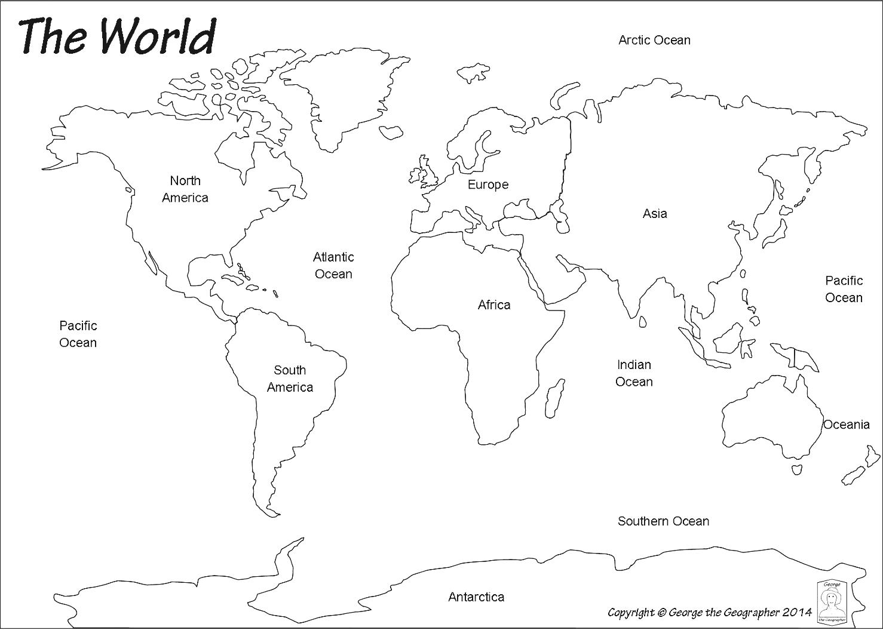

Location Activity (infinitive)

Grammar: Present Perfect
Look at the sentences below and answer the questions.
- I have climbed Mount Everest
- I have walked a tightrope across Niagara Falls
- I have swum with great white sharks three times
- I have never been on a “relaxing” holiday
- Which of these activities have you done?

- When do these activities take place? Past Present Future
- Do we know exactly when these activities happened?
- How is the Present Perfect formed?
_____________ + _________ / __________ (n’t) + ________________________

- Which of the sentences have regular past participles?
- Which of the sentences have irregular past participles?
Let’s Practice
- Complete the chart
Infinitive | Past Simple | - Past Participle
Go*
See
Be
Do
Swim
Throw
Buy
- The verb “to go” has two past participles: _______________ and _______________ .

Compare these two sentences.
- Sue has been to Tokyo.
- Marco has gone to Pilar’s office.

- Who has returned from their trip?
- Who is still at their “destination”?

Need more help?
- Student class book pg. 54, 154
- Attached worksheets

Complete the table in present perfect simple.

Positive | Negative | Question

He has written a letter
 | They have not stopped
 |  | Have we danced?

She has worked
 | Andy hasn’t slept

Write sentences in the present perfect.
- They / ask / a question ________________________________________________________________________
- He / speak / English __________________________________________________________________________
- We / not / wash / the car _______________________________________________________________________
- Annie / not / forget / her homework _______________________________________________________________

Write questions in the present perfect.
- They / finish / their homework ? _________________________________________________________________
- Sue / kiss / Ben ? ____________________________________________________________________________
- The waiter / bring / the tea _____________________________________________________________________
- Marilyn / pay / the bill _________________________________________________________________________

Ask for the information in the bold part of the sentence.
- They have talked about art at school __________________________________________________________________________________________
- Jane has got a letter __________________________________________________________________________________________
- Oliver has cooked dinner __________________________________________________________________________________________

Lesson 4 : Life Experiences

What do you like to do during the summer? Do you stay at home in the AC? Go to the beach or the mountains? Travel to new places?

Some teens have summer jobs or volunteer. Look at the job description below and then read Jack’s e-mail.
Active Summer activity courses
We are looking for high school students to work with children on our activity courses in July and August this summer.
We need instructors for the following activities:
Swimming, football, tennis, drama, art, music, photography
Courses are
Course 1: July 1st – 15th Course 2: July 16th – 31st
Course 3: August 1st – 15th Course 4: August 16th – 31st
For more information, email Mr. Smith at jobs@activesummer.co.uk
Please tell us which courses you would like to teach.

Dear Mr. Smith
I’m a high school student and I’m interested in working on your activity courses this summer.
I’m a very athletic and caring person, so I would like to work with some sports programs. I have played tennis since I was 7 seven years old and have taught it before at another summer camp. I have also trained with my local football team and we have won several matches. In fact, we won the football championship for my region.
Also, I have already worked with children. In 2014, I travelled to the south of France where I taught kids English. Last summer I babysat¹ my neighbors and we did a lot of activities. And this past break I took a course to receive my First Aid ² certificate.
I can only work during the month of July, so for Course 1 and Course 2.
Best regards,
Jack Samson

1 – to babysit (watch over somebody’s children). 2 – First Aid – primeros auxilios / secourisme

- Comprehension Questions
- What is the job advert for?

- What qualities does Jack have?

- Explain Jack’s sports experience.

- Explain Jack’s experience with kids.

- When is Jack available this summer?

- Grammar : Present Perfect vs. Past Simple

Look and compare the sentences below.
- I have trained with my local football team.
- I have played tennis since I was 7 years old.
- In 2014, I travelled to France.
- When did these actions begin? Past Present Future
- Which action is finished?
- Which action is unfinished? (still happens today)

- Never, Already, Ever

Look at the sentences below.
- Would you like some cookies? - No thanks, I have already eaten breakfast.
- Have you ever ridden a camel?
- She has never swum with sharks.

What word do we use to….
- Ask questions with present perfect?
- Say “déjà” in English?
- Say “jamais” in English?

- Let’s practice! Complete the sentences with the past simple or present perfect.

- Did you like the movie “Star Wars”? -- I don’t know. I (see, never) _________________________ that movie.
- Sam (arrive) _________________ in San Diego a week ago.
- My best friend and I (know) _________________________ each other for over fifteen years.
- Sam is from Colorado, which is hundreds of miles from the coast, so he (see, never) _________________________ the ocean.
- I (visit, never) _________________________ Africa, but I (travel) _________________________ to South America several times. The last time I (go) _________________________ to South America, I (visit) _________________________ Brazil and Peru. I (spend) _________________________ two weeks in the Amazon, (hike) _________________________ for a week near Machu Piccu, and (fly) _________________________ over the Nazca Lines.
Lesson 5 : Learn to Speak Aussie / Life Down Under
- Worksheets / activities will be provided in class.
Homework for Lesson 6 : Read the article that has been given to you in class. It is mandatory to understand the text and take notes, as you will teach your material to others in the next lesson.

Lesson 6: Jigsaw – Australian Biomes / Jobs
For this activity, you will first meet with other students who have read the same article as you. As a group, you will discuss what you learnt. Then, you will create a new, mixed group and teach your article to the others. Explain your information well and take notes! This information might be on the exam!!
Lesson 7 : Comparatives – Awesome Australian Animals part 1
What are some Australian animals that you know? Australia is a very large country and is geographically diverse (remember lesson 2?), so it’s home to over 800 different types of birds, 2 species of crocodiles, 4,000 types of fish, and 140 types of marsupials!
Let’s take a look at some Australian cuties with the infamous Steve Irwin (he was an animal lover who sadly died in the early 2000s).
YouTube Comprehension
- Where are we?
- Where do dingoes come from?
- What animal is the closet animal to a koala?
- Where does the wombat like to play?
- Are the fierce snakes venomous?
- What part of the zoo is Steve the most proud of?
Now, let’s read a text about dingoes, the first animal we saw in the video. Circle the comparatives that you find.
Dingoes – Dingoes are native to Australia and as cute as they are, they can cause lots of problems. Even though they are a mix of dog and wolf, some people keep them as pets. Since it’s a wild animal, dingoes can be more aggressive than typical dogs, and therefore have shorter life spans in nature. They can have longer lifespans if they are kept in captivity - up to 20 years – where they have a calmer, less stressful life than in the wild. These canines are bigger than dogs, and if well trained, they are more loyal than house dogs. I don’t recommend adopting a dingo, but that’s because I think dogs are friendlier and better than dingoes!
- Grammar : Comparatives
The first step to making comparatives (and superlatives in Lesson 8) is to know how many syllables an adjective has.
Take a look at the chart below and complete the rules.
** Don’t forget! We use the verb “to be” + comparative adjective + than (not that!)**

One Syllable | Ends in –y | Two or more Syllables
Short Shorter | Friendly Friendlier | Aggressive More aggressive
Calm Calmer | Lazy Lazier | Stressful Less stressful
Long Longer |  | Loyal More loyal
Rule | Rule | Rule
Add +______ to the adjective | Change ____ to ____,  And add ______ | Use ________(+) / ______(-) before the adjective
Did you notice a comparative in the text that wasn’t included in the chart? Why is it “special”? Write the original adjective and the comparative below.
Adjective | Comparative
Good
Bad
Far

- What is the rule for adjectives that end in Constant – Vowel – Constant? [CVC]

But wait! There are some irregular adjectives too.
Let’s try writing some comparatives.
- Lucy is ____________________ (old) than Ellie.
- Russia is far ____________________ (large) than the UK.
- Dogs are ____________________ (intelligent) than rabbits.
- My Latin class is ____________________ (boring) than my English class.
- In the UK, the streets are generally ____________________ (narrow) than in the USA.
- London is ____________________ (busy) than Glasglow.
What are some comparatives you can write about Australia vs. Spain? Write 3.
1.
2.
3.
Lesson 8 : Superlatives – Awesome Australian Animals pt 2
Last class we saw some pretty cute animals, but Australia is better known for the ones that give you nightmares. What scary animals do you know? Check out this article below if you’re brave!
https://www.buzzfeed.com/simoncrerar/pictures-that-prove-australia-is-the-craziest?utm_term=.dlPv4qRvO#.hbQGE75GB
Yikes! But safety is important if you ever visit Australia someday, so let’s learn about the deadliest animals in the Land Down Under.
--------------------------------------------------------------------------------------------------------------------------------------------------------------
Australia is the sixth largest country in the world (after Russia, Canada, China, USA and Brazil). However, it is the smallest of the world’s continents, and is the lowest, flattest, and driest (apart from Antarctica). Nearly 20% of the land mass is desert, with a variety of animals.
The inland taipan snake is one of the deadliest snakes in the world, but it’s also one of the rarest to find.
The thorny devil is one of the most unusual looking animals in the Australian desert.
The red kangaroo is the largest marsupial in the world, and it’s also the most famous kangaroo species. It lives in the driest parts of Australia. This kangaroo is the fastest and strongest of all kangaroo species.
------------------------------------------------------------------------------------------------------------------------------------------------------------
- Grammar : Superlatives
Just like comparatives, we need to know how many syllables an adjective has to create the correct superlative adjective.
Look and complete the table below.
** For superlatives, we use “the” before the adjective.**
One Syllable | Ends in –y | Two or more Syllables
Large Largest | Dry Driest | Unusual the most unusual
Small Smallest | Deadly | Famous the most famous
Low |  | Well-known the least well-known
Rule | Rule | Rule
Add +______ to the adjective | Change ____ to ____,  And add ______ | Use ________(+) / ______(-) before the adjective

Adjective | Comparative | Superlative
Good
Bad
Far
And let’s complete the irregular comparative / superlative table.

Finally, practice writing some superlative phrases.
- Spring is _______________________ (pleasant) time of year.
- Tom’s room is _______________________ (clean) of all.
- Jim is _______________________ (difficult) pupil in my class.
- Egypt is one of _______________________ (old) countries in the world.
- It’s _______________________ (ugly) town I’ve ever seen.
Homework Prep: With a partner, think of some possible job opportunities in Australia (sheep shearer, koala catcher, boomerang maker, shark tagger, island caretaker…) and the qualities or experience needed to hire somebody, as well as interview questions. Next class, we will make a poster and job advert to hang in the room, and later your classmates will “apply” for the job.

Lesson 9 : Creating Job Adverts
For your speaking and writing task, you will have a few tasks to complete.
- With a partner, create a job poster for a summer job in Australia. You also need to include an informational flyer with information (name of the company, type of person needed, dates to work, etc)
- With the same partner, you will need to write questions for a job interview (using present perfect and past simple)
- On Friday, we will display the posters and job adverts, and you will choose one to apply for.
- During the weekend, you must write a letter to apply for the job, and include why you are the best candidate and your experiences (using present perfect and past simple)
- Finally, you will participate in a mock interview (a fake interview) where your speaking will be evaluated.

- Look back at lesson 4 if you need some help.

Lesson 10 : Job Adverts pt. 2
In this lesson, we will display the completed job adverts from the previous class and you will choose which job you’d like to apply for. Using the job description, write an email that explains why you are suitable for the job. Make sure to use present perfect and past simple!
Job Adverts are due at the end of the hour

Lesson 11 : Job Adverts and Interview Preparation
With Tim and Ms. T, we will make sure the interview questions are correct and help you prepare for the interview!

Lesson 12 : Test Review – or – Start Interviews
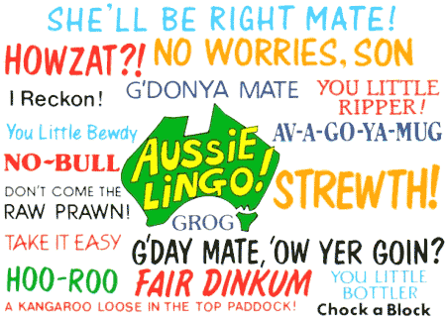
Lesson 13 : Test!
Lesson 14 : Job Interviews
Lesson 15 : Job Interviews

