Introduction to Crime Scenes
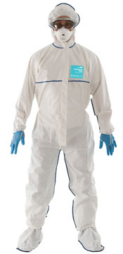
Watch the video and answer the questions.
- What is a crime scene?
- Where can a crime scene be?
- What does a crime scene investigator (CSI) do?
- Label the parts of a crime scene suit.
- What are the two purposes of the suit?

- Who is normally the first person at a crime scene? What shouldn’t he/she do?
- How does a CSI document the scene?
- What is an example of an indoor crime?
- Where is another common crime location?

Vocabulary: Read the description and match it to the correct word.
- Objects that are left behind at a crime scene. _______
- When a crime scene becomes dirty. ________
- A person who uses information to solve a crime. _______
- A person who kills somebody. ________
- A synonym for “organized”. ________
- The marks that your fingers leave behind. ________
- A molecule in your body that contains all of your genetic information. ________
- To study objects from a crime scene to find clues, or information. ________
- A synonym for “strange”. ________
- A small piece of something that you use to run tests. ________

- To analyze b. murderer c. to contaminate d. sample e. DNA
f. evidence g. tidy h. weird i. finger prints j. detective

