**TRUE OR FALSE.**

1-THERE IS A SCHOOL OPPOSITE THE HOSPITAL

2-THERE IS A GYM BETWEEN THE BANK AND THE SCHOOL

3-THE BLOCK OF FLATS ARE ON OAK STREET

4-THE LIBRARY IS NEAR THE TOWN HALL

5- THE CINEMA IS ON SECOND AVENUE

6-THE SWIMMING POOL IS OPPOSITE THE CAFÉ

**COMPLETE THE SENTENCES USING NEXT TO- OPPOSITE – BETWEEN – BEHIND - NEAR –ON**

1-THE GYM IS ………………………..THE THEATRE AND THE BANK

2-THE HOTEL IS …………………….THE PARK

3- THERE IS A CAR PARK ………………..THE HOTEL

4-THE HOSPITAL IS ………………..SECOND AVENUE

5-THE LIBRARY IS …………….THE CORNER

6-THE THEATRE IS ………………THE SUPERMARKET

7- THE SCHOOL IS ………………….THE BANK

8-THE SWIMMING POOL IS…………………THE GYM

**GIVE DIRECTIONS :COMPLETE THE DIALOGUES TAKING INTO ACCOUNT WHERE YOU LIVE ( KEY WORDS: LEFT, RIGHT, ALONG, PAST, CORNER, BETWEEN)**

1-A:CAN YOU TELL ME THE WAY TO THE GYM?

B: TURN _________ INTO MAPLE STREET. GO _______ THE LIBRARY, THE GYM IS __________THE ATRE AND THE BANK

2- A:CAN YOU TELL ME THE WAY TO THE CINEMA?

B: TURN ________. GO ________ OAK STREET. THE CINEMA IS ON THE _________. OPPOSITE THE PARK

3-A: CAN YOU TELL ME THE WAY TO THE POST OFFICE?

B: GO _________ THIRD AVENUE. GO _________ THE POLICE STATION. THE POST OFFICE IS _________ THE POLICE STATION AND THE CAFÉ

4- A:CAN YOU TELL ME THE WAY TO THE HOTEL?

B: GO _________ THIRD AVENUE, TAKE THE SECOND TURNING _________INTO PINE STREET. THE HOTEL IS ON YOUR ______

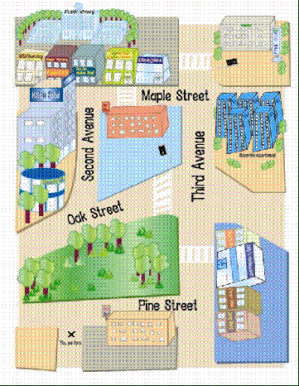

**SUPERMARKET**

**CINEMA**

**SWIMMING POOL**

**GYM**

**BANK**

**SCHOOL**

**LIBRARY**

**THEATRE**

**TOWN HALL**

**YOU LIVE HERE**

**POLICE STATION**

**CAFÉ**

**POST OFFICE**

**CAR PARK**

**HOTEL**

**HOSPITAL**