**CAN / CAN’T**

INTERROGATIVE:

CAN + Subject + Verb

Eg: Can you ride a bike?

AFFIRMATIVE:

Subject + CAN + Verb

Eg: They can run very fast.

We use CAN to talk about abilities (what people can / can’t do). Eg.: I can play the guitar.

She can play soccer.

NEGATIVE:

Subject + CANNOT + Verb (can’t)

Eg: He can’t play the piano.

1. Complete the sentences with *can or can’t.* Then, match the sentences with the pictures.

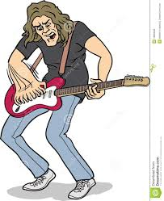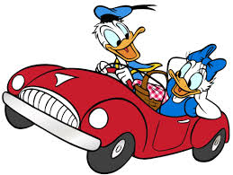

1. He _________ make biscuits………….
2. He _________ play the violin. He ________ play the guitar. …………
3. Mickey _________ make paintings. ……….
4. Bob ______ cook delicious kangreburguers. ……….
5. They _________ cook alone but they ______ cook with their mother. ………..
6. Donald _______ drive a car. …………
7. They _________ swim. ………..
8. He ___________ sing. He has a terrible voice! ………
9. He _________ speak German. …………







2. Complete these sentences about you. Use CAN / CAN’T.

a. I __________ read long books.

b. I __________ jump high.

c. I __________ play video games for many hours.

d. I __________ fly.

e. I _________ ride a bicycle.

f. I _________ play the piano.