Australian Biome: The Rainforest
The rainforest is the most diverse ecosystem on Earth yet it only covers 6% of the world's surface. A valuable resource for cultivated plants, many foods, raw materials and medicines, still each year over 20 million hectares are destroyed worldwide, logged for timber and cleared to plant crops and graze cattle. If this vital ecosystem is to survive, remaining areas of rainforest must be protected.
Australia is one of the few places in the developed world where rainforests are available for public enjoyment, global conservation and research.
Since the late 1700s much of Australia's rainforest, including 75% of its original tropical rainforest, has been cleared for agricultural, industrial and urban development. Today rainforest covers just 0.5% or 4.2 million hectares of Australia's landmass.
Every broad rainforest type is found in Australia, the driest inhabited continent on earth, where rainforests extend from the Kimberley region in Western Australia, across the Northern Territory to Cape York in Queensland and down the east coast through New South Wales and Victoria to Tasmania.
The Wet Tropics in Queensland
Over 2,800 plant species from 221 families are found in the Wet Tropics. More than 700 species (25 percent) are native to the Area. Some ancient plants in the rainforest have been around for hundreds of millions of years. The Wet Tropics provides an unparalleled living record of the ecological and evolutionary processes that shaped the flora and fauna of Australia over the past 415 million years.

The Wet Tropics is home to about a third of Australia's 315 mammal species - 13 of these species are found nowhere else in the world. They include unique green possums, ringtail possums, fierce marsupial cats, rare bats, tree-kangaroos, a rat-kangaroo, a melomys and an antechinus. There are many spectacular insects to see in the rainforest and surrounds. Do you know what a peripatus is? You can read all about the invertebrates that inhabit these forests including, crustaceans, worms, beetles, ants, spiders, mites, scorpions, amblypygids, centipedes and millipedes, not to mention the snails and slugs. While the Wet Tropics is home to a quarter of Australia's frogs and a little over a third of the country's freshwater fish, it is also home to nearly half of Australia's birds - that's more than 370 different species.

There are so many different things to see in our forests that many interesting but less visible species go unnoticed. Keep an eye out for some of the colourful forms of mushrooms and fungi that inhabit the rainforest floor. They play an important role but for most of their lives, they remain hidden inside rotting wood or in the soil - only making a cameo appearance when it is time to reproduce.

Endemic and threatened plants and animals
Many of our special Wet Tropics plants and animals are found nowhere else in the world (they are endemic to the Wet Tropics). Over 200 plant and animal species, including our iconic cassowaries are listed as threatened.

Possible Jobs in the Wet Tropics: Wildlife Protector, Biologist, Endangered Floral Species Collector, Animal Catcher and Releaser

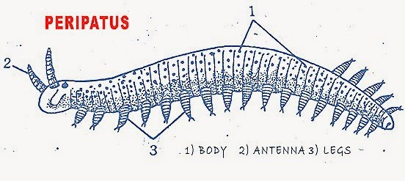
Source: http://www.wettropics.gov.au/plants-animals
Rat Kangaroo
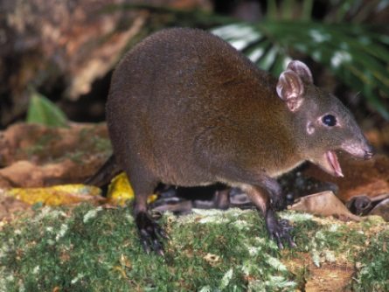
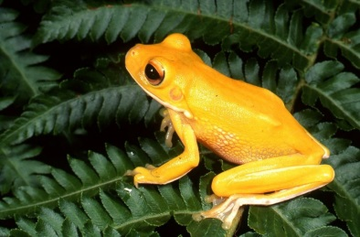
Australian Biome : The Outback (Tropical Savanna)
A home to many animals, the Australian tropical savanna is one of the world's largest tropical savannas. The world's other savannas cover two fifths of Africa and large amounts of India and South America. The Australian tropical savanna is an area of dense grass and scattered trees that stretches across northern Australia from Broome to Townsville, covering around 1.9 million square kilometres — or around one-quarter - of mainland Australia's land area.
A savanna is usually very flat and with few trees and shrubs, this is because the fires destroy most of the trees and shrubs which usually aren't fire resistant. This happens frequently during the summer. This is also because savannas across the world have a limited water supply and the bigger vegetation, such as trees, is the first to die out. Savannas usually occur only in a climate that has both a rainy and dry season. Each of these different seasons is very extreme.
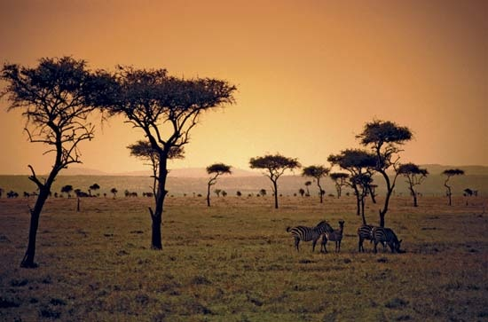
The dry seasons of the Australian savanna can last up to five months, from May to October. With each dry season come forest fires. These forest fires occur often, and geographers believe that fire keeps the savanna healthy. The tropical rain forest trees, which would have otherwise grown in that climate, don't grow because they are destroyed by the fires. Though the fires don't destroy all of the underground grasses, the fires limit the growth of any vegetation that isn't fire resistant. Usually the temperatures are cooler, with clear skies and low humidity.
During this time, water is important. The rainy season can be pretty bad too. Some savannas around the world get ten inches of rain, and some ten full feet. Some pools, ponds, lakes, rivers, and streams flood. Much of the Australian savanna rain falls in heavy bursts of thunderstorms and monsoons. During the wet season, which lasts from December to March, it is hot and humid. Temperatures can get as high as 50°C but usually stays around 30s (°C).
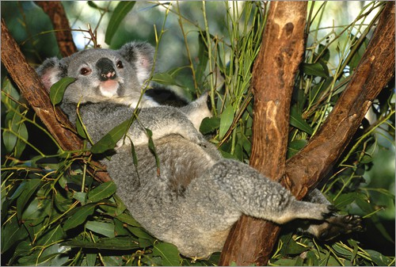
Marsupials dominate among the animals in this area of Australia. Marsupials are mammals whose young are born undeveloped, and spend months in the mother’s pouch until they become developed enough to leave. These animals include the Echidna, Eastern Gray Kangaroo, the Koala Agile and Whiptale Wallabies, Walaroos, Possums, Gliders, the Northern Qoull, and the Golden Bandicoot. These animals live in or near the few trees in this area for shade, food, and water. In the other parts of the tropical savanna, the reptiles dominate. The saltwater Crocodile, which is found here, is the world's largest reptile. It can grow to be from 7 to 8 meters long.
The vegetation in Australia differs from that of other Savannas. The acacia, part of the 1,200 members of the pea family, is the most common tree in other savannas, but is rare to find in Australia. The most common tree in Australia is the eucalyptus. They are famous for their oil, gum, and timber. The eucalyptus grows in warm climates and they are the most important tree for timber in Australia. The bark of some of these trees is used in medicine.
Koala in eucalyptus tree
There are many threats to this biome. The foreign pests and weeds that have been brought to this biome, such as the wetland weed Mimosa, threaten the survival of the region's ecosystems and native species. The Australian government has sponsored programs to clear away brush for agricultural reasons. When some of the farmers took over land, they brought with them new systems that caused some species to become endangered. The Aboriginal people have been stripped of their homes so that the government can make more room for agriculture. The World Wildlife Fund (WWF) in Australia is reacting to this destruction by working with the communities to stop the clearing programs.
Source: http://www.blueplanetbiomes.org/savanna_australia.htm
Possible Jobs in the Tropical Savanna : Marsupial Catcher, Crocodile Tagger, Savanna Tour Guide, Wildlife Protector, Park Ranger

Australian Biome : The Great Barrier Reef
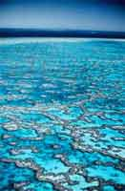
The Great Barrier Reef is the only living organic collective visible from Earth's orbit. The Great Barrier Reef, off the east coast of Australia, is one of the wonders of the natural world - it is the world's largest coral reef ecosystem. It was declared a World Heritage area in 1981 and added to the National Heritage List in 2007.
The reef is scattered with beautiful islands and idyllic coral cays and covers more than 300,000 square kilometres.
Human activity in the Reef areas has led to increased pollutants and the reef has suffered damage. Protecting the Reef is the responsibility of the Marine Park Authority. In 2003, the Government, in partnership with a wide range of industry and community groups, developed the Reef Water Quality Protection Reef Plan (the Reef Plan) as a combined effort to protect the Reef.

The coral
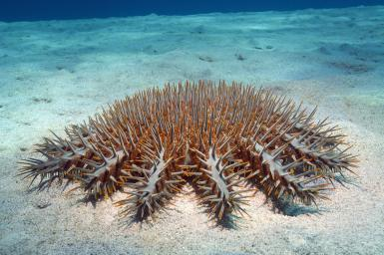
Corals make up the various reefs and are the basis for the great variety of sea and animal life in the Reef. Coral consists of individual coral polyps – tiny live creatures which join together to form colonies. The colonies join together to create forests of coloured coral in interesting shapes. The ideal environment for coral is shallow warm water where there is a lot of water movement, plenty of light, where the water is salty and low in nutrients. The colours of coral are created by algae. Only live coral is coloured - dead coral is white.
One of the greatest dangers to the habitat is the Crown of Thorns starfish. Since the 1960s the Crown of Thorns has been destroying the corals which make up the reef. Crown of Thorns outbreaks go through a series of stages which can take from 1 to 15 years. The impact of a Crown of Thorns infestation on sea and bird life can be significant as the corals die.
The coral has, over the years, brought many ships to grief. One of the most famous wrecks is that of the HMS Pandora in 1791. The Queensland Museum has been leading archaeological digs to the Pandora since 1983 and its most recent was completed in February 1999. There are 30 shipwreck sites known in the marine park.
The Habitat
The World Heritage Area hosts many habitats or native environments where animals and plants naturally live.
Different degrees of protection are provided for different habitats in the World Heritage Area. One of the main aims of the Reef Plan is to maintain biodiversity within the larger ecosystem of the Reef as well as different habitats to help sustain the biodiversity of species and population levels. The Great Barrier Reef area abounds with wildlife, including dugong and green turtles, varieties of dolphins and whales, more than 1500 species of fish, 4000 types of mollusk and more than 200 species of bird life.
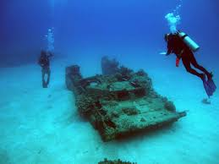
Most of the Reef is part of the Great Barrier Reef Marine Park and various parts of it are protected in certain ways. For example, fishing is restricted in some areas and particular animals – like whales, dolphins, green turtles and dugong – are protected.

Source: http://www.australia.gov.au/about-australia/australian-story/great-barrier-reef

Possible Jobs at the Great Barrier Reef: The Reef Plan volunteer, Star of Thorns Collector, Shipwreck Explorer, Animal Tagger (turtles, sharks…)

