2nde – Visual Art Unit
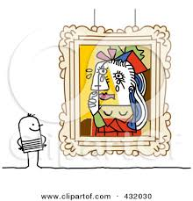
At the end of this unit, you will be able to….
- Discuss your interests in various types of visual arts
- Inform others about “hot topics” in our world and culture
- Report what somebody has told you
- Talk about past habits
- Debate whether new social media is an art form
Lesson | 2A | 2B
1 – What is art | Wed April 26 | Thurs April 27
2 – Street Art (Reported Speech 1) | Thurs April 27 | Fri April 28
3 – Grammar Practice | Wed May 3 | Tues May 2
4 – Mr. Brainwash (Reported Speech 2) | Thurs May 4 | Thurs May 4
5 – Eco Art | Mon May 8 | Fri May 5
6 – Eco Art Jigsaw | Wed May 10 | Tues May 9
7 – Body Art 1 | Thurs May 11 | Thurs May 11
8 – Body Art 2 | Mon May 15 | Fri May 12
9 – Maori Tattoos | Wed May 17 | Tues May 16
10 – New Art Forms | Thurs May 18 | Thurs May 18
11 – “Fun” Lesson | Mon May 22 | Fri May 19
12 - Selfies | Wed May 23 | Tues May 22
13 – WRITTEN EXAM | Thurs May 25 | Thurs May 25
14 – SPEAKING | Mon May 29 | Fri May 26
15 – SPEAKING / FILM / DOCUMENTARY | Wed May 31 | Mon May 29
16 - ?? | XXX | Tues May 30

!! Participation Points will FINISH on Wednesday, May 23. If you want to fulfill (or exceed) the 20 points required, take a look at the “warm up” for each lesson and prepare something to say!!
Lesson 1 – What is art?
Warm Up: When you think about art, what’s the first thing that comes to mind? What’s your favourite art form and artist? Do you enjoy going to museums?
Listen to X describe his/her interests in art and answer the following questions.
- Is X an art fanatic? Why or why not?

- Where can you see art in his/her museum?
  - Underwater b. outside c. inside

- Regarding Octavio Ocampo’s painting:
-What would you see at first glance?
-What would you see if you looked closer?

- True or False (if false, correct the adjective): The firefighters are life-sized.

- What two things can you see outside?
- How does he/she describe the Lego buildings?
  - Tiny b. colourful c. small-scale d. fascinating

- What type of art is the temporary exhibit?
- Write the two adjectives used to describe the images.
- Are you interested in art? Do you like visiting museums?
VOCABULARY: Match the words with the correct category. Can you think of any more words? Add them in the space below.
1 = Types of Art 2 = Styles of Art 3 = Places 4 = People 5 = Adjectives 6 = Phrases
___ Museum  ___ Painter  ___ Pop Art  ___ Sculpture  ___ at first glance / look  ___ Photography  ___ Colourful  ___ Realism  ___ Replica | ___ Garden  ___ Architect  ___ With a closer look  ___ Detailed  ___ Street Art  ___ Life-size  ___ Underwater  ___ (in)appropriate  ___ Enormous | ___ Sculptor  ___ Indoors – Outdoors  ___ Miniscule  ___ Black and white  ___ Art Deco  ___ Environmental Art  ___ From a different perspective  ___ in the streets | ___ Strange  ___ Permanent – Temporary  ___ Make a statement  ___ Disturbing  ___ Photographer  (fo – tahg – a – fer)  ___ Realistic  ___ Familiar  ___ it’s made of…
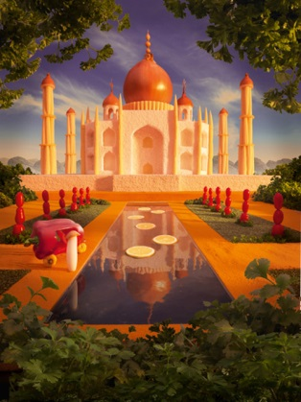
PRACTICE: Describe one of the images below in 4-6 sentences, using as many vocabulary words as you can. Why did you choose it? Do you like it? Does it mean something to you? [you can find the images in colour on Weebly]
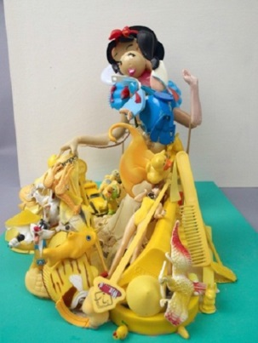
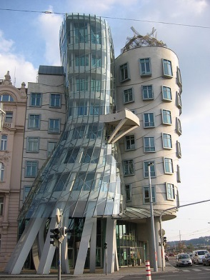
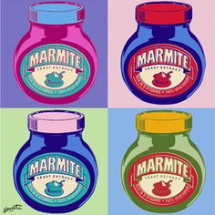
_______________________________________________________________________________________________________________________________________________________________________________________________________________________________________________________________________________________________________________________________________________________________________________________________________________________________________________________________________
HOMEWORK: Read the following article and answer the questions (also found in the class book pg. 117)
But not everyone likes street art
What is Street Art?
Street art is defined as forms of visual art created in public locations, usually unauthorized artwork executed outside of the context of traditional art venues. Spray-painted graffiti, sticker art and street installation or sculpture are common forms of modern street art. Banksy, a Bristol-born street artist, has become world-famous.
New York City Mayor Michael Bloomberg suggested Banksy was
breaking the law with his guerrilla art exhibits. Every day this month,
Banksy has been unveiling new works of art around New York. The works
are then announced on his website. Some of the surprise exhibits are
stencils spray-painted on streets and walls of buildings. Others have
included whimsical mobile¹ displays transported on trucks, an animated
YouTube video and, on Wednesday, a performance art piece involving a
dirt-smeared² boy shining the shoes of a life-sized statue of Ronald
McDonald outside one of the fast-food chain franchises.
“Graffiti does ruin people’s property and is a sign of decay³ and loss of control”, Bloomberg said at a press conference Wednesday, when asked by journalists about Banksy’s street art.
Source: www.edition.cnn.com 1 – impulsive 2 – covered in dirt 3 – decomposition
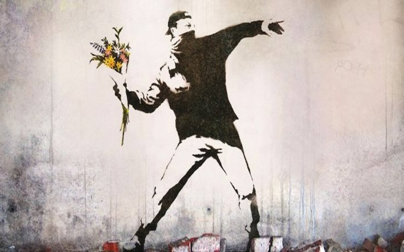
Questions
- What sort of artwork has Banksy produced in NY?

- How are new exhibits announced?

- What does Michael Bloomberg think of Banksy’s art?

LESSON 2 – STREET ART
Warm Up: Check homework. What did you learn about street art? Have you ever seen it? Do you like it? Why do you think Banksy is so popular?
Listen to an interview with some Los Angelans about Banksy’s work that has appeared in their city.
First, answer the questions.
- What has been happening in LA?
- What is Banksy’s film about? Film producers Street Artists Undercover Agents
- Where can you find some of Banksy’s art?
- What happened to the Charley Brown piece?
Alexa said that she was a huge fan and she loved Banksy’s work.
- What’s so interesting / mysterious about Banksy?
GRAMMAR: REPORTED SPEECH (1)
Reported Speech
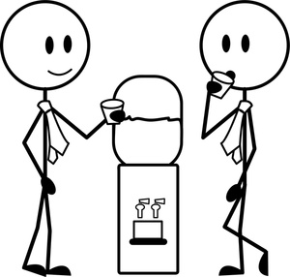
Direct Speech
I’m a huge fan and I love Banksy’s work!
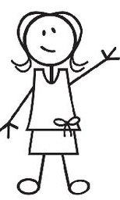

Alexa (Girl 1) Tom John
Look at the images above and answer the questions.
- What verb tense does Alexa use? Write the infinitive and the conjugation.

- What verb tense does Tom use? Write the infinitive and the conjugation.

- What subject does Tom use?

- Tom is reporting (repeating) Alexa’s words in the present / past.

GRAMMAR RULE:
When changing a sentence from direct speech to reported speech, we must:
- Change the ______________________ (Alexa : “I” Tom: “She”)
- Backshift the verbs (Put the verb into one tense in the : past future )

- Note: It’s not necessary to use “that” in reported speech.
“Alexa said (that) she was a huge fan and she loved Banksy’s work.”
BACKSHIFTING: Complete the missing verbs for Reported Speech.
Tense | Direct Speech | Reported Speech
Present Simple | “I like ice cream” | She said (that) she _________ ice cream.
Present Continuous | “I am living in London” | She said (that) she _______________ in London.
Past Simple | “I bought a car” | She said (that) she _______________ a car.
Past Continuous | “I was walking along the street” | She said (that) she ____________________ along the street.
Present Perfect | “I haven’t seen Julie” | She said (that) she ____________________ Julie.
Past Perfect* | “I had taken English lessons before” | She said (that) _______________ English lessons before.
Will | “I’ll see you later” | She said (that) she _______________ see me later.
Would* | “I would help, but….” | She said (that) she _______________ help, but…
Can | “I can speak perfect English” | She said (that) she _______________ speak perfect English.
Could* | “I could swim when I was four” | She said (that) she _______________ swim when she was four.
Might* | “I might be late” | She said (that) she _______________ be late.
Must | “I must study at the weekend” | She said (that) she _______________ study at the weekend.
*= No change
!! Must in the past ______________________
PRACTICE:
Reporter: Banksy is nominated for an Academy Award.
Verb tense in Direct: _________________ Verb tense in Reported: ___________________
Reported Speech: _____________________________________________________________________
____________________________________________________________________________________

Brittani: I’ve never seen any of his work in person.
Verb tense in Direct: _________________ Verb tense in Reported: ___________________
Reported Speech: _____________________________________________________________________
____________________________________________________________________________________

Brittani: I had to see it before it was completely destroyed.
Verb tense in Direct: _________________ Verb tense in Reported: ___________________
Reported Speech: _____________________________________________________________________
____________________________________________________________________________________
Guy: We’ve actually been looking for this spot for 45 minutes.
Verb tense in Direct: _________________ Verb tense in Reported: ___________________
Reported Speech: _____________________________________________________________________
____________________________________________________________________________________

LESSON 3: Reported Speech Practice
For this lesson, the class will be divided into three groups, which will work on different activities to perfect their English skills. Miss T will spend about 15 minutes with each group. Please stay on task during this time!
Homework: Read about Mr. Brainwash below and answer the questions.
Mr Brainwash first came to the world’s attention as the star of Banksy’s Oscar-nominated documentary Exit Through The Gift Shop. The film followed then Thierry Guetta, a perfectly ordinary French-born owner of a vintage clothes shop in Los Angeles, who had an obsessive hobby for filming things. Guetta became fascinated with the “nocturnal creatures” of his city – street artists. With the help of his cousin, the French artist Invader, Guetta became involved with the LA street art scene. The famously coy Banksy even agreed to be filmed (still hiding his identity), thinking that Guetta was making a documentary about the successful beginnings of street art.
Guetta scaled buildings, held ladders, ran from police and became a helpful, if insistent, fanboy in this strange night-time art world. He recorded hundreds of hours of footage but made no attempt to turn it into a film, and it became an unwatchable mish-mash of snapshots that gave the audience a headache.
In Exit Through the Gift Shop , Banksy says: “It was at this point I realised that [Guetta] maybe wasn’t really a filmmaker. That he was maybe just someone with mental problems who happened to have a camera.”

Banksy decided to make the documentary himself. “Why don’t you try your hand at some street art?” Banksy said to Guetta. But Britain’s giant of the art world can have had no idea how seriously Guetta would take his suggestion to become an artist. Or that in doing so Guetta would perform such a major transformation of himself and his life: he became Mr Brainwash the street artist, selling his work for thousands and putting his artist friends to shame with his overnight success.

- What is Mr. Brainwash’s real name? What are two professions he had before becoming an artist?
- Was he successful in making a documentary about street art? Why or why not?
- Who produced the film “Exit Through the Gift Shop”? What does he say about Mr. Brainwash?

- Go online and take a look at some of Mr. Brainwash’s art.
LESSON 4 : Mr. Brainwash
Warm Up: Check homework. What do you think about his work?
Read the interview with Mr. Brainwash. (back of packet, pg. )
Match the direct speech with the reported speech answers.
Direct Speech Reported Speech
____ He didn’t steal my film. A. Mr. Brainwash said that people knew him
as both names.
____ There are no rules in life, nobody can tell B. Mr. Brainwash clarified that they had been
you the rules. Involved together.
____ People know me as both names. C. Mr. Brainwash claimed that Banksy hadn’t
stolen his film.
____ If I learned anything from him, it would be passion. D. Mr. Brainwash said that there were no rules
in life, and nobody could tell you the rules.
____ No, we were involved together. E. Mr. Brainwash admitted that if he had learned
anything from Banksy, it would be passion.
GRAMMAR: REPORTED SPEECH – QUESTIONS
Just like making sentences in reported speech, you first need to backshift the verb tense and change any subjects or pronouns (I, you, me, them…)
Next, you need to change the question into a sentence : eliminate the auxiliary verb “do” (if there is one), or remove the question mark.
Remember, there are two types of questions: With question words (who, what, when..) or “yes / no” questions.
QUESTION WORDS
DS: “What is the most important thing you learned from Banksy?” – the interviewer.
RS: The interviewer asked _____________________________________________________________________.
DS: “How do you feel about Banksy stealing your film?”
RS: The interviewer asked ______________________________________________________________________.
DS: “What is the goal of your art?”
RS:_________________________________________________________________________________________.
YES / NO QUESTIONS
Because there is no question word, we use “if” to introduce the reported question.
DS: “Do you introduce yourself as Mr. Brainwash or Theirry Guetta?” – the interviewer.
RS: The interviewer asked if _____________________________________________________________________.
DS: “So you let him (Banksy) have it (the film)?” – the interviewer.
RS: The interviewer asked ______________________________________________________________________.
PRACTICE :
You friend Josh asks a lot of questions. Write them in reported speech.
1. When is the party? ___________________________________________________________________________
2. Did you go out last weekend? __________________________________________________________________
3. Where do your parents live? ___________________________________________________________________
4. Are they in Paris? ____________________________________________________________________________
5. Why do you study English? _____________________________________________________________________
6. What will you study in university? _______________________________________________________________
7. What’s the weather like in Chicago? _____________________________________________________________
8. Is it cold outside? ____________________________________________________________________________
9. Did you do your homework? ___________________________________________________________________
10. Have you studied reported speech before? ______________________________________________________
HOMEWORK: Complete Task A on the “Grasshopper and the Ants” worksheet.
LESSON 5: ECO ART JIGSAW (1)
Warm Up: Check homework.
Discuss: Earth Day was on Saturday April 22. Is the Earth important to you? Do you believe in climate change, recycling, etc? How do you help out?
TASK: JIGSAW
You will be divided into groups of three. Each group will receive one article about Eco-Art : Driftwood Art, Underwater Expos, or Garbage Art. Read the text on your own (approx. 10 mins.) and look up any unknown vocabulary. Then, with your group, discuss the text together (approx. 15 mins) and write 5-6 general comprehension questions and give them to Miss T.
Make sure that you understand and can teach your article to other students for the next lesson.

LESSON 6 : ECO-ART JIGSAW (2)
TASK: MIXED JIGSAW
For this lesson, you will be in a group with two other classmates who read different articles than you. Each person will speak for 5-7 minutes, explaining their article and taking notes of the others. (15-20 mins)
After you finish, the questions that were submitted from the previous lesson will be asked. (8 mins)
- Questions about the JigSaw WILL be on the exam!
Discuss: Is it a good idea to use recycled material for art?
Writing: Imagine that you visited one of these expositions. Tell me about what you saw, what you liked/ disliked, etc. Write your essay in about 100 words. This will be collected and evaluated. (20 mins)

LESSON 7 : BODY ART 1 – British Council “Body Conscious” Worksheets
Warm Up / Discussion / Task 1: How are some ways people can change their appearance? What do you think about hair dye, tattoos and piercings – are they attractive? Have you done any of these? Which of these do you want to do, or are totally against?
Task 2: What do you know about tattoos? Pre-reading
Task 3: Reading and comprehension questions

LESSON 8 : BODY ART 2
Warm Up: Are you interested in getting a tattoo? What would you get? Do your parents approve?
Activities: Role Plays, Discussions

LESSON 9: MAORI TATTOOS
Warm Up: Many people get tattoos as a way to express themselves. In some cultures, tattoos are sacred and represent many things. What cultures do you know about? Do you see people with cultural tattoos?
Read the article below and answer the questions.
Maori Tattoo
The Maori are an indigenous Polynesian people found in New Zealand. They have a form of body art, known as moko, more commonly known as Maori tattooing. The art form was brought by the Maori from Polynesia. This art is considered highly sacred, and continues to be highly revered.
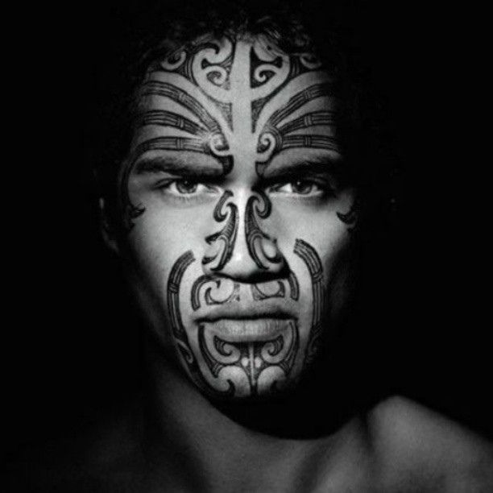
Since the Maori consider the head to be the most sacred part of the body, the most popular kind of Maori tattoo was the facial tattoo, which was composed of curved shapes and spiral patterns. It often covered the whole of the face, and was a symbol of rank, social status, power, and prestige.
For the Maori, tattooing was a rite of passage, which meant it was highly ritualized. Maori tattooing would usually begin during adolescence, and would be continually performed to celebrate important events throughout a person’s life.
Source: www.newzealandtattoo.co.nz
Questions
- Where on the body was an important Maori tattooed?

- At what time of life did the tattoo have a special meaning?

- Why are tattoos on the head considered important?

GRAMMAR: Would and past habits (and used to review)
To talk about habitual actions in the past, we can use the modal verb “would + infin”. *”would” cannot be used with a state verb (have, be, feel). [Active verbs: run, study, think]
- Maori tattooing would usually begin during adolescence.
- Maori women would get tattoos around their mouth.
- Traditional moko tattoo artists would use a sharp wooden stick, hammer and ink.
We can also use the structure “used to + infin” to describe past habitual actions. [can be used with state verbs]
- Maori tattoo artists used to be highly respected.
- Facial tattoos didn’t use to be accepted in many cultures.
- Did Native Americans use to tattoo young people?
Note –> “used to + infin” can also be used for a past truth that no longer happens.
- I used to have facial piercings (now I don’t)
- He used to have a sleeve tattoo (he got it removed)
PRACTICE: Write the sentences bellow using “would” or “used to”
1. I / have short hair when I was a teenager. ________________________________________________________________________________
2. We / go to the same little café for lunch every day when I was a student. ________________________________________________________________________________
3. She / love playing badminton before she hurt her shoulder. ________________________________________________________________________________
4. He / walk along the beach every evening before bed. ________________________________________________________________________________
5. I / always lose when I played chess with my father. ______________________________________________________________________________________

Common Maori designs

Hei matau (fish hook):
The Maori symbol fish hook symbolises prosperity. The fish hook also represents strength, determination and good health, as well as providing safe journey over water.

Koru (spiral):
The koru depicts new beginnings, growth and harmony, taken from the symbolism of an unfurled fern leaf. New Zealand has some of the most beautiful ferns in the world.

Single twist:
The Maori symbols or meaning for the single twist represents the path of lif, it is the symbol of eternity. The single figure eight is different than the double and triple twists mentioned below.

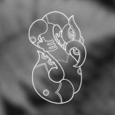

Manaia:
The manaia is known as a spiritual guardian.. Traditionally depicted as a bird like figure with the head of a bird, body of a man and the tail of a fish it acts as a provider and protector over the sky, earth and sea

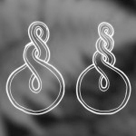
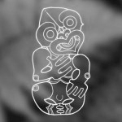
Different patterns and their meanings

Hei tiki:
Commonly known as a good luck charm the tiki is also considered a symbol of fertility. Assumed to be clear thinking, perceptive, loyal and knowledgeable, the wearers strength is their character.

Double or triple twist:
These twists represent the joining together of two people, or two cultures for eternity and even though they may experience life’s up and downs they remain bonded by friendship and loyalty for life (a favourite of the Maori symbols).

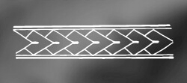  Hikuaua:  prosperity, mackerel tail.  Pakati: Dog skin cloak, representative of warriors/battles/courage and strength | 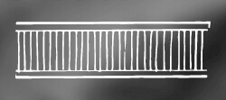  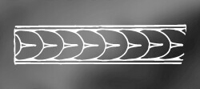  .  Taratarekae:  From whale teeth  Unaunahi: Fish scales that represent abundance and health  Unaunahi: Fish scales that represent abundance and health

LESSON 10 : NEW ART FORMS
Warm Up: What art forms have we seen so far? Do you know of other “new” art forms? Which ones?
Task: The class will be divided into two groups and each given one article (food art or yarn bombing). Read the article on your own and look up any new vocabulary words (approx. 8-10 mins). Get with your group, discuss the article, and write 5-7 comprehension questions (general and specific) from the text (8-10 mins).
Comprehension: The groups will then receive the opposite text and listen to a volunteer read it aloud. Discuss new vocabulary. The questions about the text will be asked. (approx. 8 mins). Repeat for the other group (approx. 8 mins)
LISTENING: KNit the City (book pg. 123) and discussion questions.
- What is the art form? In which city was this report made?

- What are the knitters’ objectives?

- Who is it a problem for? What is the Canadian tourists’ reaction?

- HOMEWORK: Bring in 4-6 small items (they can all fit into a grocery bag) that share a common theme (things that are important to you, things you use every day, things that are always in your backpack…). Also bring a piece of material (blanket, scarf, t-shirt, etc) for the “background” of our special activity.

LESSON 11: SURPRISE LESSON!
Please please please make sure to bring in some items that are important to you!

HOMEWORK: Read the article below about selfies. What do you think about the article?
Facebook “selfies” can harm relationships

A study says people who post too many "selfies" on Facebook may harm their real-life relationships. A selfie is a self-portrait, usually taken at arm's length or in a mirror. Britain's Birmingham University looked at how selfies affected people's relationships. Their study found that sharing too many selfies makes many people like you less. Dr David Houghton said only close friends and relatives don't mind those who constantly upload selfies.
Wikipedia says: "In 2012, Time magazine noted that selfie was among its top 10 buzzwords." Celebrities like Rihanna and Justin Bieber are famous for uploading hundreds of selfies. People who post selfies may be shocked by the research. Wikipedia says people like selfies because they can control how they look in the photo. They want to show a flattering image that their friends will like. The research may show that the opposite is true.

LESSON 12: SELFIES
Warm Up : Are you a selfie queen/king or do you roll your eyes when you see people taking a selfie? Do you think selfies are an art form? Why or why not?
Task: to be handed out on this day in class / uploaded on Weebly because Ms. T has spent about 18 hours working on this unit before class resumes on Tuesday and she is totally exhausted. But you know what? I love you oh so much! You! Yes, you! If you’re reading this, wave at me excitedly and give me the double thumbs up! (PS – It’s never too late to give me the thumbs up, you English rockstar!)

WRITTEN EXAM
Listening or Reading comprehension – Grammar : Reported Speech – Would / Used to – JIGSAW Eco-Art General Questions – Vocabulary - Recycled Grammar
SPEAKING
Describing a piece of art, how it makes you feel, etc. [10 pts]
Speaking with a partner to make a decision (B1 speaking) [10 pts]

